Creating JAR file

1.Open the maven sidebar and double-click “install”

Warning: If it gives an error ,then u need to rebuild the project. And double-click “install” again.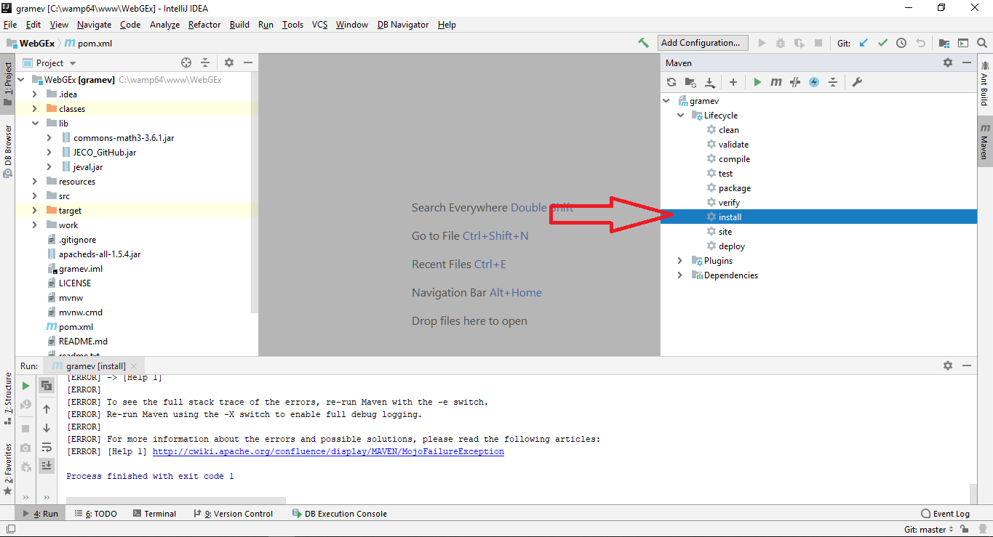

The jar will be created in the folder “target” with the name “gramev-0.0.1-SNAPSHOT.jar”.

